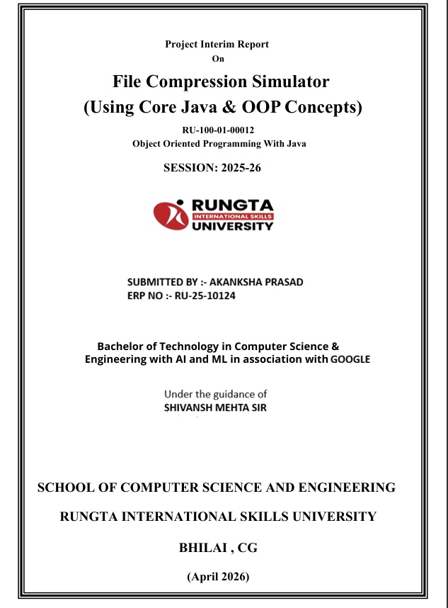

INDEX
SERIAL NO. | TITLE | PAGE NO.
(1.) | ABSTRACT | 3
(2.) | INTRODUCTION | 4
(3.) | OBJECTIVE | 5
(4.) | SCOPE | 6
(5.) | SYSTEM REQUIREMENT | 7
(6.) | METHODLOGY | 8
(7.) | FLOWCHART | 9
(8.) | CLASS NAME | 10
(9.) | IMPLEMENTATION | 11-14
(10.) | CONCLUSION | 15
(11.) | REFERENCE | 16

ABSTRACT

The Digital Wallet Payment System is a simple Java-based application developed using basic Object-Oriented Programming (OOP) concepts. A digital wallet is an electronic system that allows users to store money and perform financial transactions such as deposits and fund transfers. This project is designed to simulate a real-world digital payment system in a simplified way, making it suitable for beginners who are learning Java programming.
In today’s fast-growing digital world, online transactions have become very important. Traditional methods of handling cash are time-consuming and less secure. Therefore, digital wallets provide a faster, safer, and more convenient way to manage money. This project demonstrates how such a system can be implemented using simple programming techniques without using complex features like private variables or advanced exception handling.
The system allows users to deposit money into their wallet and transfer funds from one wallet to another. It also includes a cashback feature, where users receive 2% cashback on every successful transaction. This feature makes the system more realistic and engaging. The project uses basic concepts like classes, objects, and methods to perform operations, making it easy to understand and implement.
Overall, this project helps in understanding the fundamentals of Java and OOP concepts. It provides a strong base for developing more advanced financial applications in the future.

INTRODUCTION

A Digital Wallet Payment System is an electronic application that allows users to store money digitally and perform financial transactions such as depositing and transferring funds. With the rapid growth of technology and the increasing use of online payment methods, digital wallets have become an essential part of everyday life. They provide a fast, secure, and convenient way to handle money without the need for physical cash.
This project focuses on developing a simple Digital Wallet Payment System using Java programming language and basic Object-Oriented Programming (OOP) concepts. The main aim of this project is to demonstrate how digital transactions can be performed using simple logic and programming techniques. The system is designed in a beginner-friendly way, without using advanced concepts like private variables or complex exception handling, so that it is easy to understand.
The application allows users to create wallet objects, deposit money into their wallets, and transfer funds from one wallet to another. During the transfer process, a cashback feature is also implemented, where a small percentage (2%) of the transaction amount is returned to the sender. This simulates real-world digital wallet applications and makes the project more practical.
This project highlights the use of classes and objects, which are fundamental concepts of OOP. It also shows how methods are used to perform operations like deposit and transfer. Overall, the Digital Wallet Payment System serves as a basic model for understanding how modern financial systems work and provides a foundation for building more advanced applications in the future.

OBJECTIVE

- To develop a simple Digital Wallet Payment System using Java
- To manage user wallet records (balance management)
- To track transactions such as deposits and money transfers (similar to tracking issued records)
- To reduce manual work and perform operations digitally
- To implement basic Object-Oriented Programming (OOP) concepts like class and object
- To provide a cashback feature on transactions
- To make the system easy to understand and user-friendly for beginners

SCOPE

The Digital Wallet Payment System is designed for learning and educational purposes. It helps students understand basic Java programming and Object-Oriented Programming (OOP) concepts in a simple and practical way. The system allows users to perform basic operations like depositing money and transferring funds between wallets.
This project is suitable for small-scale use where simple digital transactions are required. It can be used as a base model to understand how real-world digital payment systems work. The current system does not include advanced features like security, database storage, or user authentication, but it provides a strong foundation for further development.
In the future, the scope of this project can be expanded by adding:
- User login and authentication
- Database integration for storing user data
- Transaction history tracking
- Mobile or web-based interface
- Enhanced security features
Thus, the project has good potential for improvement and can be developed into a complete real-world application.

SYSTEM REQUIREMENTS

Hardware Requirements
Computer or Laptop
Minimum 4 GB RAM
Processor: Intel i3 or above
Keyboard and Monitor
Software Requirements
Operating System: Windows / Linux / macOS
Java Development Kit (JDK)
IDE (VS Code / Eclipse / IntelliJ IDEA)
Any text editor (optional)
Other Requirements
Basic knowledge of Java programming
Understanding of simple OOP concepts (class and object)

METHODOLOGY

The Digital Wallet Payment System works in a step-by-step process using simple Java programming. The methodology followed in this project is explained below:
- Create Wallet Objects
First, wallet objects are created using the Wallet class. Each object represents a user wallet with its own balance.
- Initialize Balance
The wallet starts with zero balance. Money is added using the deposit method.
- Deposit Money
The user deposits money into the wallet. The balance increases based on the deposited amount.
- Transfer Money
The user transfers money from one wallet to another. The system checks whether sufficient balance is available before performing the transfer.
- Update Balances
After a successful transfer, the sender’s balance decreases and the receiver’s balance increases.
- Apply Cashback
A cashback of 2% is calculated on the transferred amount and added back to the sender’s wallet.
- Display Output
Finally, the updated balances of both wallets are displayed on the screen.

FLOWCHART

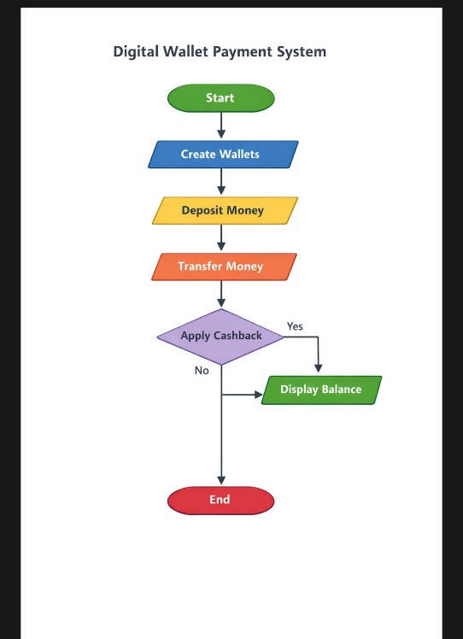

CLASS NAME

The class name used in this program is Student.
A class is a blueprint used to create objects and define properties and behaviors. The Student class represents a student entity in the system.
Variables Inside Class
The variables inside the class are used to store data related to the object. These are also called instance variables.
In the Student class, the following variables are used:
int id → stores the student ID
String name → stores the student name
int marks → stores the student marks
These variables hold the information of each student object separately.
Method in Class
Methods are functions defined inside a class that perform specific operations.
In the Student class, the following methods are used:
Set Data() → Used to assign values to variables like id, name, and marks.
display() → Used to display the student details on the screen.
Methods help in organizing the logic and performing operations on the data stored in variables.

IMPLEMENTATION
1. Classes Used in the Program
1. Main Class (Driver Class)
This class controls the complete flow of the program. It contains the main method where execution starts. It displays menu options to the user (like add, view, search, update, delete records) and calls other classes or methods based on user choice.
2. Data Class (e.g., Student / Book / Employee Class)
This class is used to store details of each record.
It contains variables like ID, name, and other required fields.
It also includes methods to set and get values (getters/setters).
This class represents a single object (one record).
3. Management Class (e.g., Record Manager / Library Class)
This class handles all operations on records.
Main responsibilities:
Add new record
Display all records
Search a record
Update details
Delete record
It uses arrays or Array List to store multiple records.
2. Logic Explanation
The program starts from the main method.
A menu is displayed to the user.
User enters a choice.
Based on the choice:
Data is taken as input
Loop is used so the program runs until user experience.
3. Sample Input / Output
Input:
Copy code:- 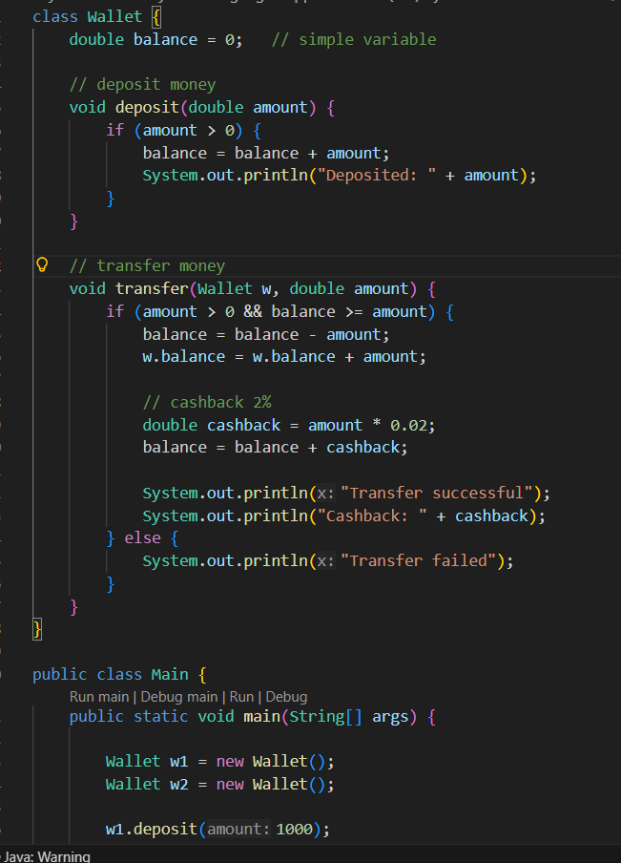
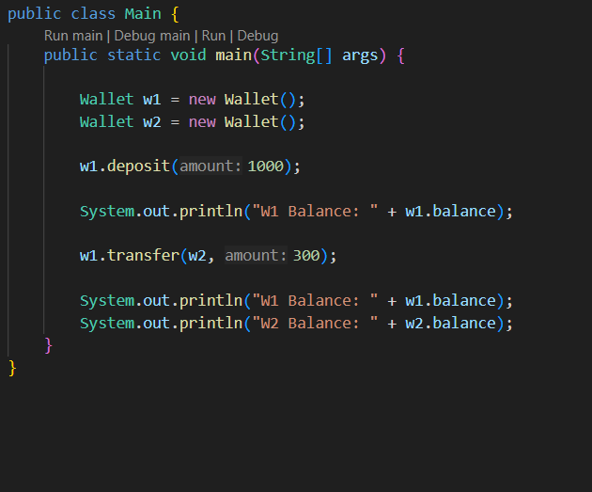

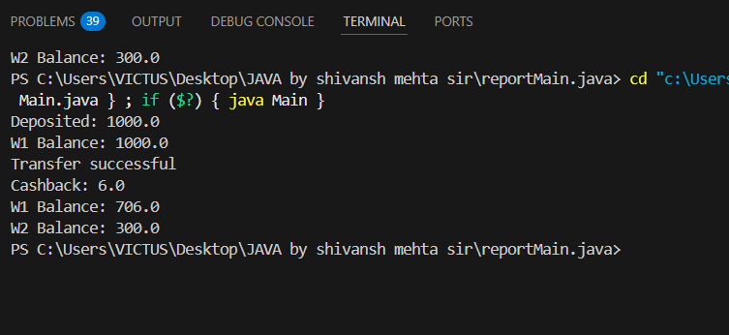

5. Future Enhancements
Add GUI using Java Swing
Store data in database (MySQL) instead of memory
Add login system for security
Improve user interface
Add file handling for permanent storage
6. Improvements
Code can be optimized for better performance
Error handling can be improved
More validation can be added (like invalid input check)
Make program more user-friendly

CONCLUSION

The Digital Wallet Payment System project successfully demonstrates the use of basic Java programming and Object-Oriented Programming (OOP) concepts. It provides a simple and effective way to perform digital transactions such as depositing money and transferring funds between wallets. The inclusion of a cashback feature makes the system more realistic and practical.
This project helps in understanding how real-world digital payment systems work in a simplified manner. It also improves programming skills by applying concepts like classes, objects, and methods. The system is easy to use and suitable for beginners, as it avoids complex features and focuses on simple logic.
Overall, the project achieves its objective of creating a basic digital wallet system. It can be further enhanced by adding advanced features such as security, database storage, and user authentication, making it more useful for real-world applications.

REFERENCE
- The development of the Digital Wallet Payment System is based on fundamental concepts of Java programming and Object-Oriented Programming (OOP). The following references were used to understand and implement the concepts effectively:

- Herbert Schildt, Java: The Complete Reference, McGraw-Hill Education
A comprehensive guide covering core Java concepts including classes, objects, constructors, and arrays.
- E. Balagurusamy, Programming with Java, McGraw-Hill
Provides clear explanations of OOP principles and practical examples useful for beginners.
- Oracle Documentation, Java Platform Standard Edition Documentation
Official documentation for Java syntax, libraries, and programming standards.
- Online Learning Platforms:
Tutorials and examples from websites such as:
- GeeksforGeeks
- W3Schools
- TutorialsPoint
These platforms helped in understanding implementation techniques and resolving errors.
- Lecture Notes and Classroom Materials
College-provided notes and examples were used as a foundation for understanding basic programming logic and structure.

